Sandvik Coromant Sustainability Information
  - This document describes the sustainability approach of Sandvik Coromant and provides relevant information to frequently asked questions.

2026

Content
Sustainability statement 1
General information 2
Our sustainability approach 3
Frequently asked questions 5
Sustainability performance, ratings and reporting 5
Reports & key figures 5
International frameworks 5
EcoVadis 5
CDP 5
Global Compact 6
FTSE4Good 6
Governance and compliance 6
Code of Conduct 6
Supplier Code of Conduct 6
Business Partner Code of Conduct 7
Policies 7
Conflict minerals and cobalt 7
Conflict minerals 7
Cobalt 8
Net zero and environmental management 8
Net zero and energy 8
Environmental management 9
Health & safety 9
Circularity 9
Labor and Human Rights 10
Supplier engagement 10
Continuous improvement 11

Sustainability statement
The future of manufacturing is net zero, circular, and efficient
The world needs sustainable manufacturing, and our industry needs to become part of the solution. Together with our customers and partners, we are redefining the landscape of component manufacturing by creating value today to ensure a thriving, resilient future for both the industry and society at large.
Through the right mix of people, knowledge and technology, we pioneer solutions that propel manufacturing towards net zero, circularity, and resource efficiency. Our expertise lies in designing superior tools and data-driven machining technology that boosts productivity while cutting material and energy waste across the entire value chain.
We focus on continuous improvement across five key areas: sustainable solutions, net zero, circularity, people and communities, and responsible business.
Together, we are committed to fostering a culture of sustainability at Sandvik Coromant. We believe that by working collaboratively with our employees, customers, suppliers, and other stakeholders, we can achieve our sustainability goals and create long-term value for all. We are proud of the progress we have made, but we recognize that there is always more to do. We invite you to join us on this journey towards a more sustainable and resilient future. Together, we can make a difference.
The purpose of this sustainability information is to provide our stakeholders with a clear and comprehensive overview of our sustainability policies, management approach, and practices. It aims to address frequently asked questions. By sharing this information, we seek to foster transparency, build trust, and highlight our ongoing commitment to sustainable development.

Sincerely,
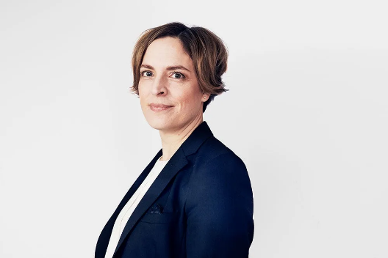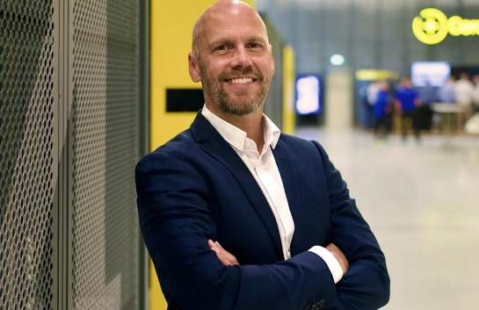
Helen Blomqvist Patrik Eurenius
President Head of Sustainability & EHS

General information
More than metal-cutting tool manufacturers, we’re the engineers of tomorrow.
Sandvik Coromant is at the forefront of manufacturing tools, machining solutions and knowledge that drive industry standards and innovations demanded by the metalworking industry now and into the next industrial era. Educational support, extensive R&D investment and strong customer partnerships ensure the development of machining technologies that change, lead and drive the future of manufacturing.
Headquartered in Sandviken in Sweden, Sandvik Coromant is a business area segment within Sandvik Machining and Manufacturing Solutions, one of three business areas of Sandvik Group. Sandvik – a global, high-tech engineering group with about 41.000 employees. Sandvik Coromant employs around 7000 people in 150 countries. We have over 54000 products on the shelf, introduce yearly around 2500 new products and hold around 1700 patents.
With 80 years of expertise, we embrace a holistic approach to manufacturing, called manufacturing wellness. This mindset values balance and well-being, helping companies thrive, be resilient, and create lasting change. We apply this to everything we do, from reducing costs and waste to enhancing efficiency and circularity.
Please read more about our governance structure in Sandvik´s corporate governance report.

Our approach

Sustainability is continuously being integrated in our business and fully aligned with expectations from both our internal and external stakeholders — including Sandvik Group's sustainability goals.
Our focus is to support customers in analyzing the climate impact of their metal cutting and manufacturing operations and taking action to reduce their climate footprint, as well as driving circularity and resource efficiency, doing more with less and working towards circular value chains. By working closely with customers and partners we aim to address concrete challenges and ensure we are a responsible business partner. Through the right mix of people, knowledge and technology, we take responsibility to limit our environmental impact in our own operations. We believe in the power of high-performing teams, that knowledge grows when it is shared and that we always put safety first. We also minimize our risk by ensuring compliance with sustainability and EHS regulations.
Our focus areas are sustainable solutions, net zero, circularity, people and communities, and responsible business.
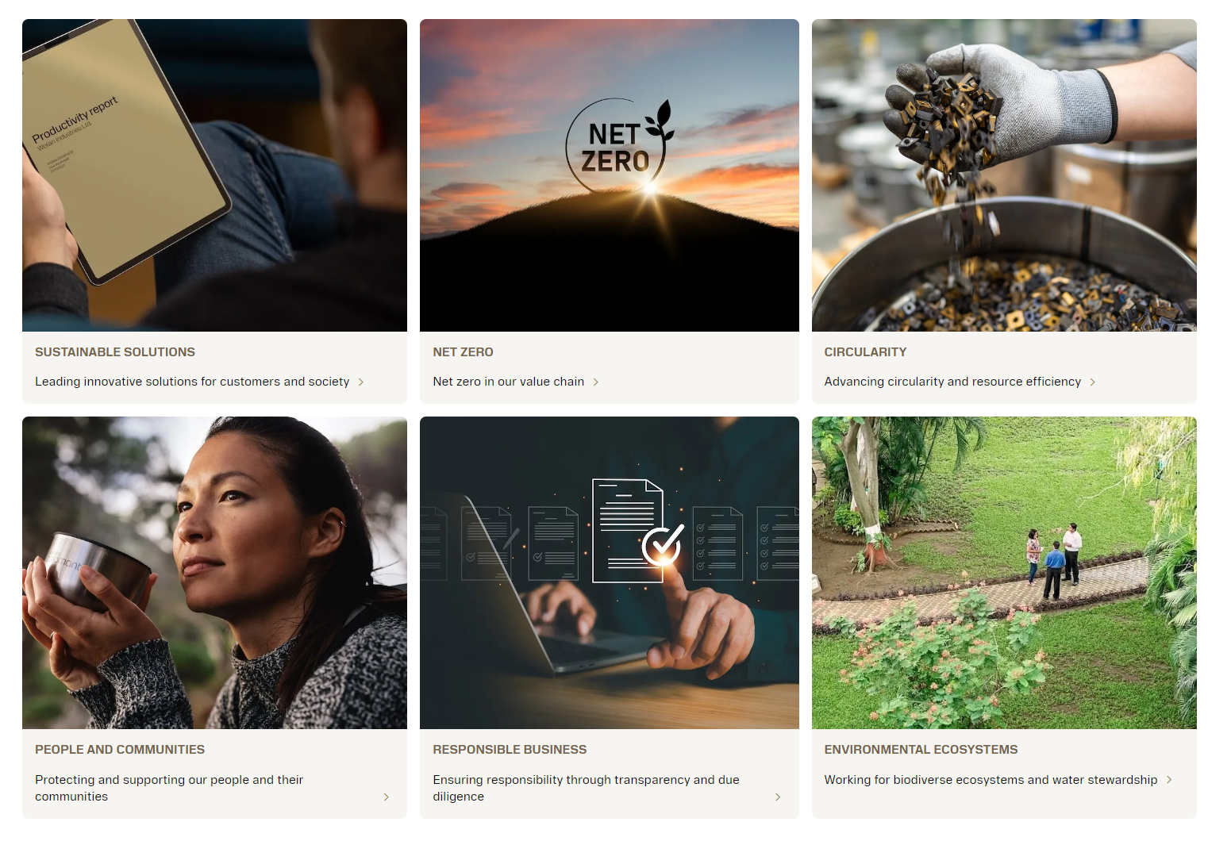
Our people are the key to implementing the roadmap and achieving our goals for sustainability. Through strategic partnerships, we leverage knowledge and data to set a new way of working. By following the Sustainability Shift, we aim to contribute to the fulfilment of the Paris Agreement targets and the UN Sustainable Development Goals relevant to our industry.
Our main goals to accelerate sustainability at Sandvik Coromant are shown below. Please find more information our our website.

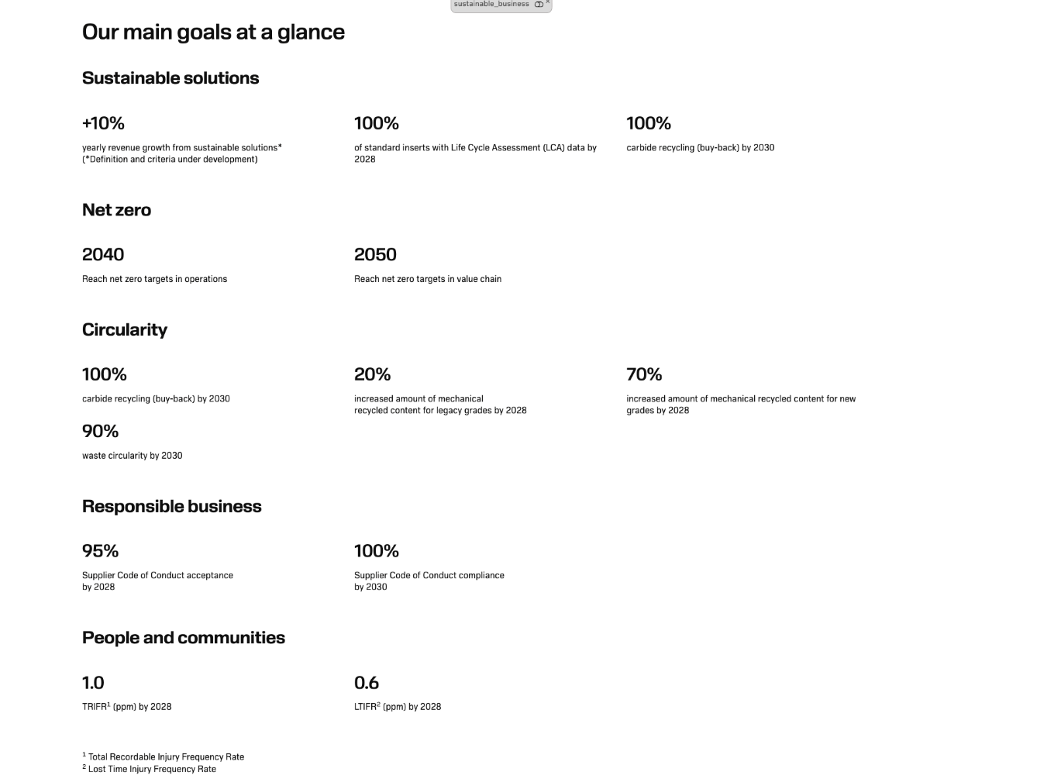

Frequently asked questions
In this chapter you will find answers to commonly asked questions on our approach.

Sustainability performance, ratings and reporting
Through Sandvik Group, Sandvik Coromant is part of various strategic partnerships to advance our sustainability commitments, ratings, and reporting.

Reports & key figures
Please find all relevant reports and key figures (on Group level) on our website and in our annual report. The annual report is done in accordance with the EU Taxonomy, CSRD, and the GRI reporting guidelines. Additionally, we disclose relevant key figures and our main goals, including our net zero commitment in accordance with the Science-based targets initiative (SBTi) for Sandvik Coromant on our sustainable business website.

International frameworks
As an international and responsible company, we are committed to the global sustainability agenda. We have aligned our sustainable business roadmap with both the UN Sustainable Development Goals (SDGs) as well as the Paris Agreement, e.g. through the Science-based Target Initiative (SBTi).
Through Sandvik Group, we are included in several sustainability indices and support a number of international principles and commitments. This is an important recognition of our efforts in the area of sustainable business. It also shows our customers that we are a sustainable supplier, striving to make them more sustainable as well. Please find more information here.

EcoVadis
EcoVadis is a globally trusted provider of business sustainability ratings and provides assessments on how well a company has integrated sustainability into its business and management systems. The assessment covers a wide range of topics, including environment, labor and human rights, ethics and sustainable procurement. Their methodology is based on leading standards such as ISO 26000 and GRI.
Through Sandvik Group, we report our sustainability metrics and progress on a yearly basis. For 2025, Scored Silver meaning top 15%. More information can be found in the EcoVadis report on our website.

CDP
Through Sandvik Group we disclose our environmental impact through CDP, a non-profit organization that runs a global leading environmental disclosure platform. CDP is used by, for example, companies, states and cities to disclose their environmental data as well as track and benchmark progress.
For 2025, we received score C, please find more detailed information in the CDP report on our website.

Global Compact
We support the Global Compact, a voluntary initiative based on a commitment to implement universal sustainability principles and to take steps to support UN sustainability goals, through Sandvik Group. Sandvik has been a participant since 2013.

FTSE4Good
Through Sandvik Group we are a constituent of the prestigious FTSE4Good Index Series, an index that measures Environmental, Social and Governance (ESG) performance practices in companies worldwide.
Integrity Next
Integrity Next is a supplier platform that supports supply chain compliance in accordance with global sustainability standards and covers topics like supply chain due diligence, decarbonization, and deforestation. We support customers with questionnaires on this platform.
Supplier Assurance
Supplier Assurance is a supplier platform for supply chain traceability that addresses human rights supply chain traceability & due diligence requirements to meet the demands of evolving global supply chain legislation such as UFLPA and the German Due Diligence Act. We support customers with questionnaires on this platform.

Governance and compliance
We are committed to ensuring high standards of business ethics and responsibility throughout our value chain, enabled by transparency and due diligence. We continually set higher standards for ethics and transparency, striving to lead by example in fairness and openness. Our goal is to foster a responsible and sustainable value chain, working closely with our suppliers and customers. By conducting our business with honesty and integrity, we aim to not only meet but exceed stakeholder expectations and legal requirements.

Code of Conduct
Our Sandvik Group Code of Conduct describes the principles of behavior that all our employees should aspire to and provides us with practical guidance in our actions and everyday business decisions. It is a very important building block of our overall governance structure and supported by policies and procedures to further detail our internal requirements and rules and can be found here.

Supplier Code of Conduct
Sandvik is committed to contributing to sustainable development for present and future generations. This includes identifying, preventing, mitigating, and accounting for adverse environmental, human rights and governance impacts in our own operation and supply chain. We expect the same commitment from our suppliers. The Sandvik Group Supplier Code of Conduct applies to our suppliers and service providers. The latest version of the Sandvik Supplier Code of Conduct is valid from April 2024 and can be found here.

Business Partner Code of Conduct
The Sandvik Group Business Partner Code of Conduct applies to our distributors, resellers, sales agents, traders or other partners as well as in joint ventures. The latest version of the Sandvik Business Partner Code of Conduct is valid from April 2024 and can be found here.

Policies
We have a number of mandatory policies, valid for all parts of the Sandvik organization. Below you find our public sustainability-related policies.
EHS Policy
The EHS Policy applies to all operational Environmental, Health and Safety (EHS) activities. This includes all internal operations as well as external services that Sandvik provides to the market place such as sales and services. It applies globally to all entities within the Sandvik Group and covers all employees, contracted workers and visitors to Sandvik facilities. The signed and dated EHS policy can be found here.
Anti-Bribery and Anti-Corruption Policy
The Anti-Bribery and Anti-Corruption Policy sets forth our commitment to preventing and detecting bribery and corruption wherever it may arise. This policy applies to all employees, directors, officers of all entities within the Sandvik Group including joint ventures Sandvik controls and anyone acting on behalf of such entities and can be found here.
Speak Up Policy
The purpose of the Speak Up Policy is to explain how employees and other stakeholders can raise concerns (Speak-up) about suspected breaches of Sandvik´s Code, policies and the law without fear of retaliation and can be found here.
Risk Management Policy
The purpose of the Risk Management Policy is to establish a systematic and integrated approach to risk management throughout the Sandvik Group and can be found here.

Conflict minerals and cobalt

Conflict minerals
Conflict minerals are the 3TG: Tin, Tantalum, Tungsten, and Gold and their ores, independent of origin. Sandvik Coromant has 3TG (mainly tungsten) in all hard metal products.
The ores of tin (cassiterite), tantalum (columbite-tantalite, coltan) and tungsten (wolframite) as well as gold may originate from conflict affected and high risk areas (CAHRA), as specified in the US Frank-Dodd Act Section 1502 or in the OECD Due Diligence Guidance for Responsible Minerals Supply Chains.
Sandvik is a member of the Responsible Minerals Initiative (RMI), one of the most utilized and respected resources for companies from a range of industries addressing responsible mineral sourcing issues in the supply chain. In line with the RMI´s due diligence approach we conduct yearly investigations between November and March and compile our results into the Conflict Minerals Reporting Template (CMRT).
Our statement on responsible sourcing of minerals and metals can be found here or on our website.

Cobalt
Even though cobalt is not identified as a conflict mineral, around 74% of the world´s mined cobalt is produced in the Democratic Republic of the Congo (DRC) , which is a conflict affected and high risk area.
Sandvik Coromant is monitoring the responsible sourcing of cobalt in the same way as we monitor the 3TG, through the Responsible Minerals Initiative. The Cobalt Reporting Template (CMRT) and the Extended Minerals Reporting Template (EMRT) are updated yearly.

Net zero and environmental management

Net zero and energy
We are committed to reducing emissions throughout our entire value chain – from sourcing raw materials to producing and transporting our products. By tracking emissions data and monitoring energy consumption in all our facilities, we enable informed, fact-based decisions that significantly reduce the climate impact of our business. Recognizing the vital roles our customers and suppliers have in sustainability, we offer our expertise to improve their operations and prepare for a sustainable future. This includes boosting operation efficiency and establishing ambitious climate reduction goals across the value chain.
We are striving for net zero in our value chain and have set net zero targets in line with the Paris Agreement and according to the Science-based target initative (SBTi). We aim to be net zero in our own operations by 2040 (Scope 1 and Scope 2) and in our value chain by 2050 (Scope 3), with 2019 as our base year. We support our customers in increasing productivity, efficiency and optimisation with proven climate impact reduction. We also take responsibility within our own operations and have started the shift towards fossil-free electricity, implemented energy saving activities, and decreased our CO2 emissions by more than half since 2019.
We are currently conducting a Life Cycle Assessment (LCA) on our product base with a focus on inserts. The projects aim is to provide third-party verified product carbon footprint for majority of our inserts assortment in the mid 2027 and progress to include the whole assortment. Additionally, we provide Use Phase calculations for our customers through our Tool Guide.
We monitor and track energy consumption and have programs and procedures to reduce energy use. We are currently working on a revised energy policy regarding nuclear energy in our energy mix. We buy Guarantees of Origin (GoO) for Europe through Sandvik Group. We are currently not a member of RE100.
Energy consumption data (on Group level) can be found here. Local energy certificates for selected sites are available upon request.

Environmental management
Our management system assesses environmental risks associated with production and ensures that measures for environmental protection are implemented, guided by our EHS Policies and procedures. We comply with local environmental laws and our own procedures, and we hold up-to-date ISO 14001. Environmental policies, practices, and expectations are communicated to all employees and suppliers in appropriate languages.
We have developed a data-driven assessment tool called Green Factory, which is used at all our manufacturing sites to monitor and assess the environmental impact of each site, covering materials, emissions, working environment, facilities and local impact. The tool has been used since 2019 and is based on a number of standards including the 17 UN Sustainable Developments Goals. All KPIs are followed up in our Environment, Health & Safety (EHS) system on a quarterly basis.
We measure emissions to air, water, and other mediums. Our air emissions are managed through established systems, and we have pollution prevention devices on chimneys, vents, and extraction systems.
We also have programs and procedures to reduce water use, reuse, and recycle water, and our facility treats wastewater before off-site discharge. To further minimize pollution and waste, we have programs and procedures in place, including those for managing and disposing of hazardous waste (e.g from hard metal scrap), wastewater, solid waste, and airborne emissions.

Health & safety
Zero harm is our first priority. All Sandvik Coromant production units are certified according to ISO 45001 Occupational Health and Safety Management Systems. The certificates are available for download here.
We have written health and safety procedures as well as objectives to improve the health and safety performance in place. Additionally, we set an annual health and safety plan that reflects objectives, targets and actions to improve performance. By 2028 we aim to achieve a Total Recordable Injury Frequency Rate (TRIFR) of 1 ppm, and a Lost Time Injury Frequency Rate (LTIFR) of 0,6 ppm respectively. TRIFR and LTIFR are tracked on site level and disclosed on Group level in our annual report.
Detailed information on the following product safety information can be found here:
- Mechanical/physical hazards
- Dust and fume hazards
- Sensitizing hazards
- Specific chemicals in products
- Preventive measures
For further information and a complete list with relevant products and article numbers see the relevant documents on our website.

Circularity
We are driving circularity and resource efficiency, doing more with less and working towards circular value chains. We minimize waste and environmental impact throughout the value chain by reconditioning products, as well as reducing, reusing, and implementing recycled materials in products and production. We also help our customers and suppliers improve their sustainable practices and guide them on their journey by offering to recycle with our buy-back program, recondition solid carbide round tools, and reduce materials and waste by improving tool performance and reliability.
Through Sandvik Group we have set a circularity target (including waste) of 90 % by 2030. We aim to buy back 100 % of our products by 2030 and increase the amount of mechanical recycled content for our legacy grades to 20 % and for new grades to 70 % by 2028.
In 2025, we have achieved 83 % waste recycling globally. We use recycled material in our products, for instance our steel turning inserts contain at least over 65 % recycled carbide, recovered through our recycling operations in Austria and India. Additionally, we use recycled plastics in our tooling packaging (HDPE, 95 % recycled content). Both our tooling and SRT packaging is recyclable. Our packaging uses various materials to protect products effectively. While all plastics can be recycled technically, recycling availability varies by region due to differing markets. We are currently improving our packaging approach and exploring new partnerships and collaborations.
Mor information can be found on our website.

Labor and Human Rights
At Sandvik, we are committed to a coordinated and structured approach to human rights, as outlined in our Human Rights Commitment and this policy. We ensure compliance with legal and regulatory requirements while recognizing that each area is managed by different parts of our business through specific underlying policies in each Key Human Rights Area.

We place specific efforts on those rights that are at risk of being most severely impacted by our activities and business relationships and have currently identified five key areas of salient human rights across the entire value chain. The Key Human Rights Areas of Sandvik at present are:
- Labor Rights and Fair Working Conditions
- Health & Safety
- Environment
- Anti-Corruption
- Affected Communities

Find more detailed information in our Group-wide approach on our website. Country specific reports can be found here: Country-specific reports and policy statements.

Supplier engagement
At Sandvik Coromant we are committed to identifying, preventing, mitigating, and accounting for adverse environmental, human rights and governance impacts in our own operation and supply chain. We expect the same commitment from our suppliers.
All business relations between Sandvik and our suppliers must be based on honesty, trust, and cooperation. It is important for us to partner with suppliers who understand and embrace our sustainability standards. The standards are about protecting the environment, mitigating climate change, building circularity as well as respecting human and labor rights and committing to conducting business with high ethical integrity. We encourage our suppliers to strive towards continual improvement and work together with us in building a sustainable business.
The Sandvik Supplier Code of Conduct applies to our suppliers and service providers. The latest version of the Sandvik Supplier Code of Conduct is valid from June 14, 2021. As part of our sustainability strategy, we have a commitment to ensure that all suppliers comply with our Supplier Code of Conduct by 2030.
The Sandvik Statement on Responsible Sourcing of Minerals and Metals can be found here.
Please read more about our supplier management here.

Continuous improvement
All Sandvik Coromant production units are certified according to ISO 9001 Quality Management Systems, ISO 14001 Environmental Management Systems, as well as ISO 45001 Occupational Health and Safety Management Systems. The certificates are available for download here. Furthermore, we adhere to the ISO 50001 energy management standard on our sites in Renningen and Schmalkalden. The certificates can be found on our website.
All parts of Sandvik Coromant are subject to internal audits which we are conducting annually to monitor the effectiveness of our management systems for Quality, Environment, Health and Safety based on a three-year audit plan that is reviewed regularly. The audits cover areas like systems, processes, products, suppliers, and service providers, and are related to ISO 9001, ISO 14001, ISO 45001, and ISO 50001. Our management systems are certified by a third-party, Intertek AB.
Sandvik Coromant does not hold formal certificates from accredited sources for any American Petroleum Institute (API) specifications or other professional organizations like A2LA, ASME, or NADCAP. As a tool manufacturer, NADCAP certification is not applicable. Conformance certificates for products are available upon request, and manufacturer conformance certificates are provided for special products. All traceability information, including batch and serial numbers, are indicated on the conformance certificates.
Sandvik Coromant is currently not planning to implement any additional certifications beyond the aforementioned.

